Final Project Design Phase
Computer Science - Week 11
Oct 3, 2026 - Version 0.0.4

For complete instructions and project ideas, refer to the assignment in Canvas. Specifically, review the final project requirements before you continue below. If you have not reviewed the project requirements in Canvas (you might have to go to the modules view and check the current or past week's content), you will not be able to properly complete the parts below. In addition, it may be helpful to review the information on this Drafter documentation page.

0) Project Planning and Preparation
Successful programmers spend time planning before they begin coding. After reviewing the project requirements, answer the following questions to help guide your design and development process.
- What concepts from class or previous assignments might help you complete this project? Which programming concepts (loops, conditionals, lists, classes, etc.) do you expect to use? What programming skills do you want to improve while completing this project?
I expect to use lists, dataclasses, conditionals, and probably some other stuff. I want to improve my python/drafter abilities.

- Which parts of the project do you expect to be the easiest for you? The hardest? Why?
Making dataclasses, and functions should be pretty easy.

Making it appear on screen in a formatted manner might be difficult.

- Even though you have not yet designed the final project, estimate which tasks will likely require the most time and effort? Which features or components should be implemented first?
Figuring out a dashboard to display all hosts with their own respective data will probably take a while. The first thing to implement should be the dataclasses like state, and probably a navigation bar.

- What distractions might interfere with your work and how will you minimize them? What resources will you need available while working? What questions, if any, do you still have about the assignment requirements?
Distractions may include instagram reels, but really I enjoy python so it shouldn't be a huge distraction. Resources I think ill need is probably some paper and a pencil to help visualize how everything will interact, and a nice comfy seat.

1) Site Diagram
Create a mock-up of your planned website. We suggest you make the mockup on paper, although you can also use software like PowerPoint or Slides to make a mockup. There is other design software that could also be used, but we strongly encourage you to keep it simple. Do not spend more than 15-30 minutes detailing the mock-up. Your goal should be to make a very quick and dirty diagram, to show that you have some kind of idea.

We recommend drawing each page as a rectangle, and laying out the text, buttons, and other components inside. Then, use arrows to indicate links between pages. Label each page the way you will name each function, and then put labels on the arrows to indicate what the button links. Also write down any parameters that should come into the pages.

In addition to the pages and routes, write down what fields your `State` will have, both their names and types. Think clearly about what data will need to be persistent across the entire website.

Add photo(s) or screenshot(s) of your website mock-up and labeled diagram on the next page.

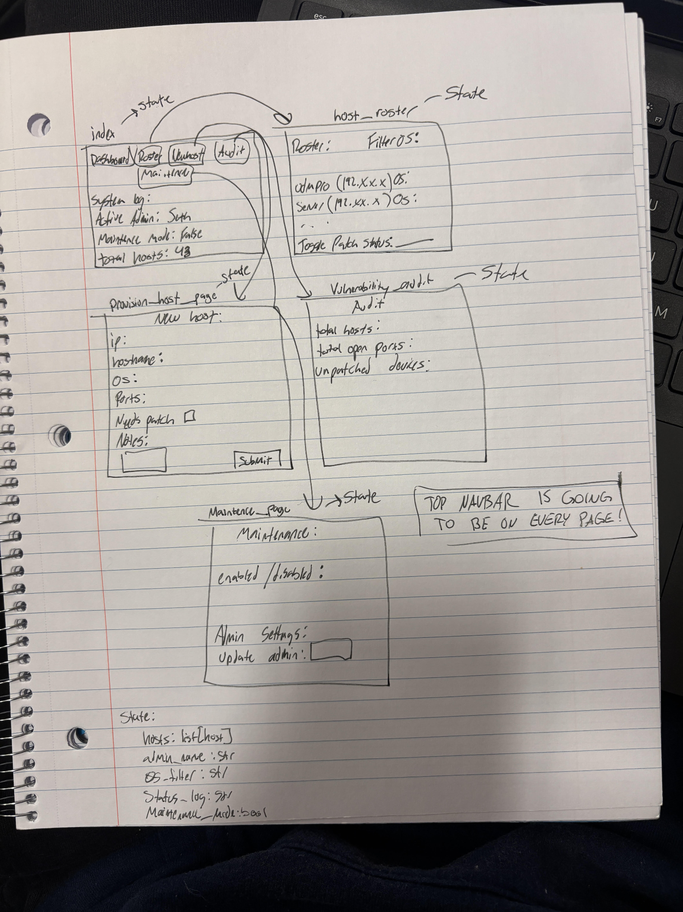

2) Implementing Requirements
This table should serve as a draft for how you will implement the requirements into your final project. You may change your ideas later on, but your final site must fulfill all the requirements.

Requirement | Implementation
Purpose/Functionality  A 1-2 sentence description of the purpose or functionality of your site | For network administrators to be able to cleanly and effectively inventory and keep track of hosts on their network.
State Dataclass Attributes  Minimum of 4 attributes, one of which must be a list/dict of instances of your second dataclass.  Briefly describe each attribute, its type, and how it will be meaningfully modified throughout the site. | Hosts: list[Host]  (a list of hosts provisioned by the user, this is modified by adding more hosts to the list)  Admin_name: str  (this is a visual thing, it tells you who is the admin of the site)  Selected_os_filter: str  (this will help the user filter through all of the hosts on the site)  Status_log: str  (tells the user what the last action was)  Maintenance_mode: bool  (determines whether or not you can change certain things)
Second Dataclass  Your second dataclass, including its attributes, their types, and how they will be meaningfully modified (if they are modified) | Host  hostname : str  (the name of the device, this can be used to find devices in the list of all devices)  ip_address: str  (this is the ip of the host, this is not modified except when provisioning the device)  os_type: str  (more details on the host, not changed, but can be filtered)  open_port_count: int  (this is the number of open ports on the host, this is used later on the vulnerability screen)  needs_patching: bool  (this is whether or not the host needs a patch, this can be changed when the user updates the machine)  notes: str  (anything the user wants to add, services running, random caveats in the device, etc.)
Routes (minimum 7)  The names of your route functions | Index  Maintenance_page  Update_admin  Toggle_maintenance  Host_roster  Apply_os_filter  toggle_patch_status  Provision_host_page  Save_new_host  Vulnerability_audit
Pages (minimum 5)  A brief description of the pages in your site | Dashboard (shows the title of the site, current system admin, whether or not maintenance mode is on, and the total number of provisioned hosts.)  Host Roster(shows all hosts and the information that was provided during the provisioning process)  Provision New Host(Where the user adds new hosts to the site, and where they input all the necessary information)  Vulnerability Audit(shows all open ports across devices, number of unpatches devices, and other data)  Maintenance mode (this is where you can toggle maintenance mode and update the admin name.
User Input (minimum 3)  Description of user input components (TextBox, TextArea, CheckBox, or SelectBox) and their purposes  For more information on these input types, see Drafter Documentation. | On the provision new host page, there is textbox inputs for the user, there is a drop down for picking the OS, and a checkbox for whether or not the systems needs patched.
If Statements (minimum 3)  Brief description of what will be evaluated in your if statements and how they will meaningfully change the logic of the site | I will have a if statement checking whether maintenance mode is True, if it is then the user can update the admin name.  I will have an if statement to make sure the user can not enter an empty string for the admin name. If they try to enter an empty string the system log will display an error message on screen.  There will be an if statement for the OS filter to see if hosts match the filter, then they are displayed.
Loop (minimum 1)  This loop must iterate over the list/dict of dataclass instances in your State attribute.  Description of this loop and why it is meaningful to the site | When the user patches a system, they need to update it on the site. They will search by hostname and there will be a for loop to go through the hosts to find the one that matches the hostname so they can toggle the patch status.

LLM Conversation
If you used an LLM in any part of this work, copy and paste every part of that conversation below. Otherwise, you may be given a zero for the assignment. Obviously, these words will not all be yours, and this is the exception to the requirement at the top of this assignment that all responses be in your own words. If you did not use an LLM to assist you in this assignment, simply say so below.
For my network inventory drafter site, what are some routes and pages i will need
For your Network Inventory Drafter site, I’d recommend organizing it around a simple goal: letting a user keep track of network devices, view their details, and see basic information about their network.

Since you're building this in Drafter for a CS1 project, keep the routes simple and focus on features that work with Python and browser storage rather than a complicated backend.

Recommended routes and pages
Switchboard, your whole fleet, one control plane · Scylos | Scylos

1. Home / Dashboard

Route: /

The main landing page that gives the user an overview of their inventory.

Total number of devices

Counts by device type

Quick links to add or view devices

Basic inventory summary

Network Scanner & Monitoring Tool for Home and Office | Fing

2. Device Inventory

Route: /inventory

The main page where users can see all their saved network devices.

Device name or hostname

IP address

Device type (router, switch, computer, printer)

Status (active, inactive, or unknown)

Search or filter devices

New Device - No Fuss Computing

3. Add Device

Route: /add-device

A form for adding a new device to the inventory.

Hostname

IP address

Device type

Location or notes

Input validation and a save button

Reyee RG-E5 Review | HighSpeedInternet.com

4. Device Details

Route: /device/{id} conceptually

Shows the information for one selected device.

All stored device details

Edit device information

Delete device

Return to the inventory

What is ITAM? A Guide to Successful IT Asset Management

5. Reports / Statistics

Route: /reports

A simple analysis page that turns inventory data into useful summaries.

Devices grouped by type

Active versus inactive device counts

A bar chart using Drafter's graphing support

Using the Organization Inventory - Cisco Meraki Documentation

6. Settings / Data Management — optional

Route: /settings

A small utility page for managing locally stored inventory data.

Export inventory to a CSV file

Clear saved inventory with confirmation

Show a short explanation of where data is stored

How the routes fit together
Here is a possible navigation structure for your app:

Dashboard /

Inventory

/inventory

Add Device

/add-device

Reports

/reports

Settings

/settings

Selecting a device in Inventory opens its details page.

Which pages should you build first?
For a three-week introductory programming project, I would prioritize these four:

Priority

Page

Why

1

Dashboard

Gives users a clear starting point

2

Inventory

Implements the core functionality

3

Add Device

Provides the input needed to create records

4

Device Details

Makes each record useful and manageable

Add Reports once the basic inventory works. Settings can be a stretch goal.

One important Drafter consideration: Drafter runs Python in the browser using Pyodide, so you can store inventory records in browser local storage. That works well for a personal inventory on one browser, but it does not provide a shared inventory across multiple users or computers automatically. Also, use Drafter's actual page and navigation mechanisms when implementing these conceptual routes; URL patterns like /device/{id} are illustrative, not guaranteed to work as dynamic routes out of the box.

My recommendation is to make the Inventory page the centerpiece and have adding, viewing, editing, deleting, searching, and counting devices all work reliably before adding advanced networking features.

what are some cool features to include within each page
For your Network Inventory Drafter site, I’d add features that make it feel like a real network admin dashboard, not just a collection of forms and tables. The trick is choosing features that look impressive but are still realistic for a CS1 project using Python, Drafter, and browser local storage.

Cool features for each page
1. Dashboard — make it feel alive
NetTopo 3D AI — Intelligent Network Monitoring Platform

AI-driven Network Intelligence Framework - JADE NEXUS

6 Top Asset Inventory Management Software Tools

Live-feeling stat cards

Show total devices, routers, switches, computers, and devices marked inactive. Recalculate the numbers whenever the inventory changes.

Easy
Network health score

Create a simple score based on the percentage of devices marked active and how many records are missing important information. Label it as an inventory health score, not a real network security assessment.

Medium
Recently added devices

Display the three most recently added devices using a saved creation date.

Easy
Attention needed

Automatically flag devices with missing IP addresses, duplicate IP addresses, or an unknown status.

Easy–Medium
2. Inventory — make managing devices satisfying
Custom Filters for Network Monitoring – Domotz

Infraon Infinity Software Reviews, Demo & Pricing - 2026

Tiimi – Company Asset Management for SaaS-Based HR Systems by Bagus Fikri for Fikri Studio on Dribbble

Instant search: Find devices by hostname, IP address, or device type.

Smart filters: Filter by device type, location, or status.

Sortable columns: Sort by hostname, IP address, or date added.

Duplicate IP warning: Highlight devices that share the same IP address.

Table/grid toggle: Switch between a traditional table and visual device cards.

Bulk selection: Select several devices to mark their inventory status at once.

My favorite: Combine search, filters, and colored status badges. It is relatively straightforward in Python but makes the page feel much more professional.

3. Add Device — make data entry smarter
IT 기기, PC 자산 관리 번호 부여 방법

Smart form validation

Check that the hostname isn't empty and that an IPv4 address follows the expected format.

Device type presets

Let users select a router, switch, server, workstation, printer, or access point, with an icon for each type.

Location tagging

Let users enter a building, room, lab, or office so they can later filter devices by location.

Add another device

After saving, offer a button to add another device without navigating back to the dashboard.

A particularly nice touch: show a small device preview that updates as the user fills out the form.

4. Device Details — make each device useful
Release 1.2.0 | Infrahub Documentation

Device identity card: Show a large device icon, hostname, device type, and status.

Copy IP button: Copy the IP address to the clipboard.

Editable notes: Record details like purpose, room, or maintenance notes.

Device age: Show how long ago the record was added.

Change status: Mark a device active, inactive, under maintenance, or unknown.

Delete confirmation: Ask before deleting a device so users don't accidentally lose their data.

Related devices: Show devices in the same room or location.

For CS1, I'd implement editing and deleting first, then add the copy button and related-device feature.

5. Reports — turn your inventory into insights
Cherwell Asset Management Alternatives and Competitors: Performance, UX, and More

Panaseer | Cisco Networking App Marketplace

Highlights of the New USU IT Asset Management Platform

Devices by type

Use a bar chart to compare routers, switches, servers, and computers.

Status breakdown

Visualize the percentage of devices marked active, inactive, or under maintenance.

Inventory audit report

List duplicate IP addresses, missing fields, and incomplete records.

Export to CSV

Download the inventory so users can open it in a spreadsheet.

Drafter's Python graphing support makes this page a good place to demonstrate data processing, especially if you use lists or dictionaries to organize your devices.

6. Settings — useful quality-of-life features
Export/import inventory: Back up records as a file and restore them later.

Demo data button: Populate the app with sample routers, switches, and computers for testing.

Reset inventory: Clear all locally saved devices after a confirmation step.

Display preferences: Choose light/dark appearance or table/card view if you implement the controls yourself.

Remember that local storage is specific to the browser on that device. Exporting a backup is especially useful because your inventory isn't automatically synchronized to another computer.

My recommended feature set
If I were planning this project, I'd pick features that demonstrate different programming skills without making the project too large.

Choose your features
Select the features you want in your project to build a manageable scope.

Dashboard statistics

Easy
Lists, loops, counting

Search and filters

Easy
Strings, conditions

Add/edit/delete devices

Medium
Functions, dictionaries, state

IP validation and duplicate detection

Medium
String processing, comparisons

Charts and audit report

Medium
Data processing, graphing

CSV export

Medium
File handling, formatting

Real network scanning

Hard
Networking, permissions, external access

5 features selected

One important distinction: inventory status is not the same as live network status. You can reliably let users mark a device as active or inactive in your app, but automatically discovering devices or pinging IP addresses may not be possible from Drafter's browser-based environment. I'd make the inventory management features excellent first, then consider a small interactive network map or other visual feature as a stretch goal.

Final Submission
When you are finished, download this file as a Word Document (docx) and upload the file to the appropriate assignment on Canvas.

